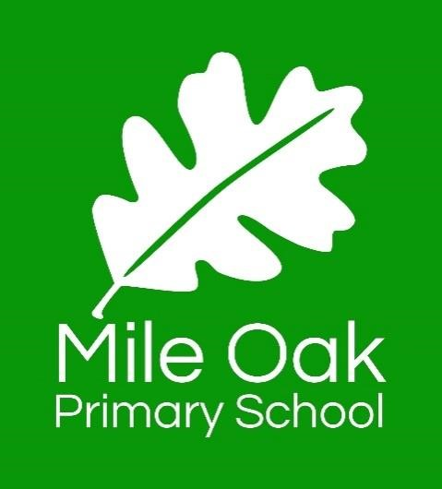

Our children leave Mile Oak thinking big with no limit on their potential. The school family works together to inspire and support every child. They learn and achieve through inspirational teaching in a lively, ambitious environment. Every child is nurtured to gain the creativity, responsibility and full breadth of skills required to take an active and fulfilling role in society.

Mile Oak Primary School:
Assessment Policy
Date | September 2026
Review Date | September 2027

1. Key Principles for Assessment
Assessment is integral to high-quality teaching and learning. All assessments used to inform decisions about pupil learning is high-quality and provided with a clear purpose.

Across our school, we will ensure that:

- Assessment is fair, inclusive and free from bias.
- Assessment complies with National Curriculum expectations.
- Assessment is open, honest and transparent.
- Assessment secures high expectations for all.
- Assessment is appropriate to age, task and desired information.
- Assessment is accurate and consistent.
- Assessment supports comparison with other schools, both locally and nationally.
- Assessment outcomes provide meaningful and understandable information for pupils, parents and school staff

Before assessing pupils we consider these three steps:
- The construct: We identify the specific knowledge, skill or understanding (drawn from the curriculum) that we intend to assess
- The end use: We identify what we want to do - the interpretation, the decision or action - with the information generated by the assessment process
- The best tool: We identify the most appropriate, effective and efficient way to assess in each instance

(Evidence based education)

2. Approaches to Assessment

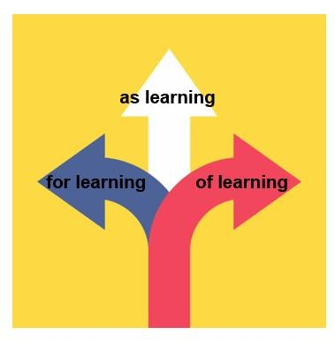
At Mile Oak assessment is an integral part of teaching and learning, and it is inextricably linked to our curriculum.
We use three broad overarching forms of assessment:
- Assessment for Learning - in-school formative assessment
- Assessment of Learning in-school summative assessment and nationally standardised summative assessment
- Assessment as Learning – effective use of retrieval practice as part of the learning process

3. Validity
To ensure staff are able to infer relevant findings from assessments we ensure the assessments are fit for purpose and that there are no barriers to performance outside of the intended measure e.g. language.

As a leadership team, we ensure the marking ranges used in standardised assessments are appropriate and meaningful through regular evaluation.

4. Reliability
To increase reliability of assessments we;
- participate in standardisation activities
- use exemplars
- blind moderate
- moderate within the cluster
- moderate across the city

5. Value
Before assessing pupils we consider the value the assessment will offer to the teaching and learning experiences of our pupils.
“It is well-designed, purposeful, planned assessments which bridges the gap between teaching and learning.”
(Evidence-Based Education, 2021)

6. Celebration
We celebrate progress. Assessment enables pupils to see the distance they have travelled and this is deeply rewarding for them

7. In-School Formative Assessment
Effective in-school formative assessment enables:
- Staff to effectively design powerful learning experiences which maximise progress within and between lessons. All staff use assessment to provide timely, effective intervention through both support and challenge
- Pupils to use self-assessment and peer assess to measure their knowledge and understanding against learning objectives and by using success criteria to identify areas in which they need to improve. It demonstrates the knowledge and skills to be retained for later retrieval
- Parents to gain a broad picture of where their child’s strengths and weaknesses lie, and what they need to do to improve

Day-to-day in-school formative assessment, (see T&L Policy) for examples:
- Diagnostic assessment
- High-quality conversation
- Effective questioning
- Listening
- Observing (process over product)
- Use of mini whiteboards
- Marking of pupils’ work – including with the pupils
- Scanning work for pupil attainment and development
- Live marking
- Low stakes quizzing

2.2 In-School Formal Summative Assessment

Effective in-school summative assessment enables:
- School leaders to monitor the performance of pupil cohorts, identify where interventions may be required, and work with teachers to ensure pupils are supported to achieve sufficient progress and attainment
- Staff to evaluate learning at the end of a unit or period and employ question level analysis to inform future learning
- Teachers to review ‘Data, So What?’ Action Plans half termly.
- Pupils to understand how well they have learned and understood a topic or course of work taught over a period of time. It should be used to provide feedback on how they can improve.
- Pupils to apply previous learning in unfamiliar situations, develop resilience and retrieval strategies
- Parents to stay informed about the achievement, progress and wider outcomes of their child across a period

Target Sheets
Target sheets are used to plan and assess from in all subject areas.

- Maths Target sheets in the front of maths books
- Writing Target sheets in the front of the learning journals and independent writing books
- Reading Target sheets in the front of reading journals
- Curriculum target sheets

2.3 Nationally standardised summative assessment
Nationally standardised summative assessment enables:
- School leaders to monitor the performance of pupil cohorts, identify where interventions may be required, and work with teachers to ensure pupils are supported to achieve sufficient progress and attainment
- Teachers to understand national expectations and assess their own performance in the broader national context
- Pupils and parents to understand how pupils are performing in comparison to pupils nationally

Nationally standardised summative assessments include:
- Early Years Foundation Stage (EYFS) profile at the end of reception
- Phonics screening check in year 1
- National Curriculum tests and teacher assessments at the end of Key Stage 2 (year 6)

4. Reporting to Parents

Teachers will report pupils’ attainment levels at parent consultations, including SEN consultations. End of year levels will also be put onto the end of year pupil report to parents, which will also include:

- How pupils have achieved in relation to the Key Performance Indicators and areas for development in the form of ‘Next Steps’ in reading, writing and maths.
- Arrangements for discussing the report with the pupil’s teacher
- Along with the end of year report to parents, an attendance record will also be enclosed, providing parents with:
  - The total number of possible attendances for that pupil, and
  - The total number of unauthorised absences for that pupil, expressed as a percentage of the possible attendances
- The results of any public examinations taken, by subject and grade

5. Feedback for Learning – refer to the Feedback for Learning Policy

6. Target Setting Overview

Targets are set for the beginning of the year for all year groups (1 – 6) as part of the ‘Data, So What?’ and appraisal process. They will be set for Reading, Writing and Maths across the school, as well as a target for diminishing the gap for disadvantaged learners. These are subsequently reviewed half termly.

Assessment Tests
At the end of the autumn, spring and summer terms, a test will be administered to support teacher assessment and provide pupils with the opportunity for test practice. It will not solely form the basis of assessment, but will complement the other strands of assessment that are carried out.

All results and QLA are passed to the next year group to support transition.

Procedures
All assessments are updated 3 times per year, at the end of each term.
SLT (including SENDCO) and teachers analyse this data and discuss support allocated to pupils at termly pupil progress meeting (PPMs).

Pupil Groups
SLT, Middle Leaders, Subject Leaders and Teachers must track progress across the subject areas and focus on analysing outcomes by pupil group.

Assessments and progress is logged using an online data tracker: Sonar Tracker.

At each assessment point, teachers identify whether children are working:
B = ‘Beginning’ to grasp the age-related expectations of their current year group
JA = ‘Just At’ age-related expectations for their year group at this point in the year
At = ‘At’ securely at age-related expectation for their year group at this point in the year
Above = Working at Greater Depth for their year group at this point in the year

Any children working at a level below their year group, will be assessed against curriculum expectations for the appropriate year.

Phonics
Phonics tracking sheets to be completed for all children on the phonics programme

8. Pupil Progress Meetings

Reports
The following reports should be used to support dialogue at PPMs and to track with a focus on pupil groups:
- Venn diagram
- Age-Related Expectation Summary Report
- Subject specific Age Related Reports
- Steps progress between terms
- Conversion reports
- Diminishing differences report

DHT, SENDco and teachers attend PPMs.

9. Teaching and Learning Assessment Report

Termly assessment data is reported to governors at Teaching and Learning committee meetings.

