Transition Booklet



Moving into Year 4

When I come back after the summer holiday, I will be in Year 4 with my new class.

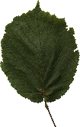My new class will be called Hazel Class.

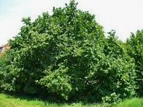Hazel is a type of tree.

My new classroom is in the Junior side of the school.

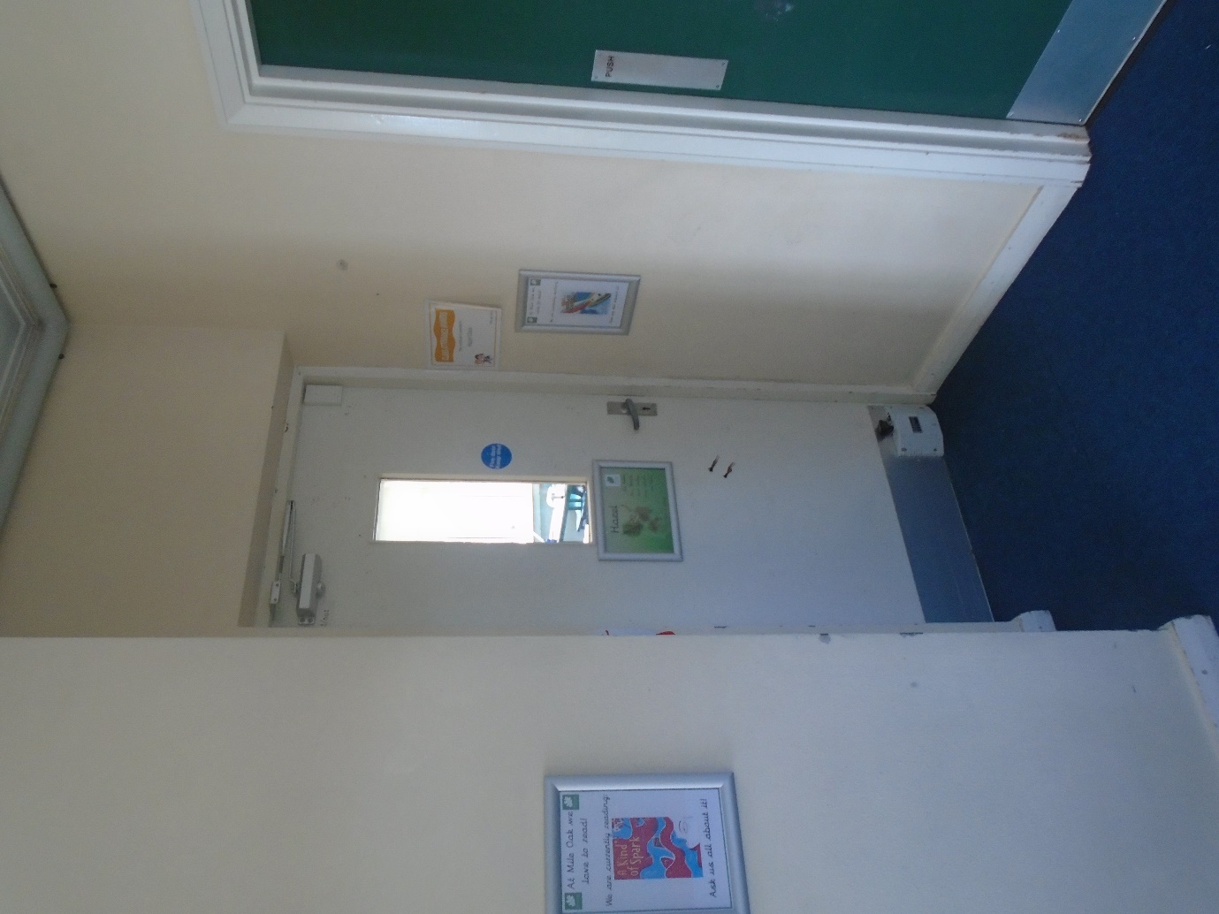

My new teachers will be Mrs. Croghan and Miss Murray.

Mrs. Croghan will teach me on Monday and Tuesday.

Miss Murray will teach me on Wednesday, Thursday and Friday.

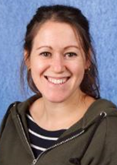This is Mrs. Croghan. This is Miss Murray.



Mrs Dyson and Mrs Wilcock be my Teaching Assistants.

They will help me with my work and I can talk to them if I have any

questions or problems.

This is Mrs Dyson This is Mrs Wilcock

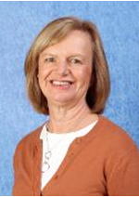

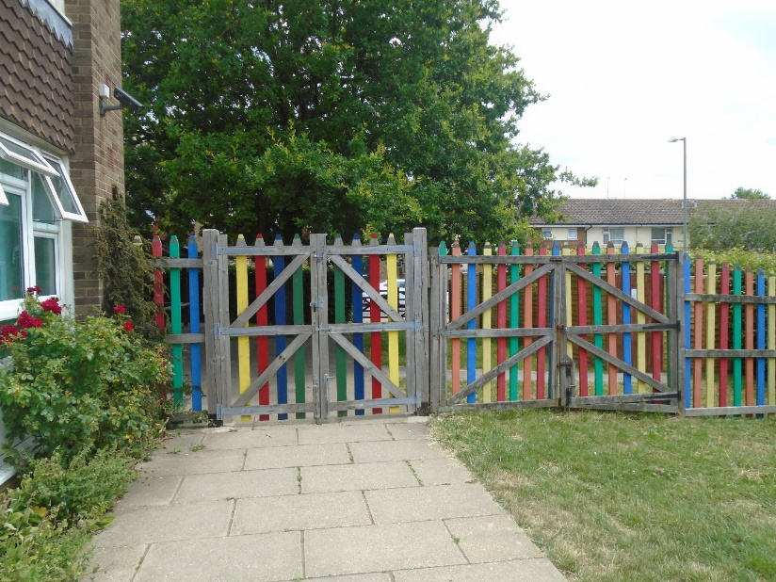I will come in the school through the junior gate and go straight to my classroom.

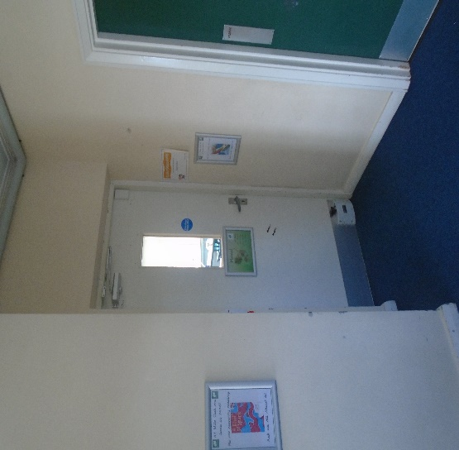We will line up here and go through this door which leads to our classroom.

I will use the toilets and coat pegs along the corridor.

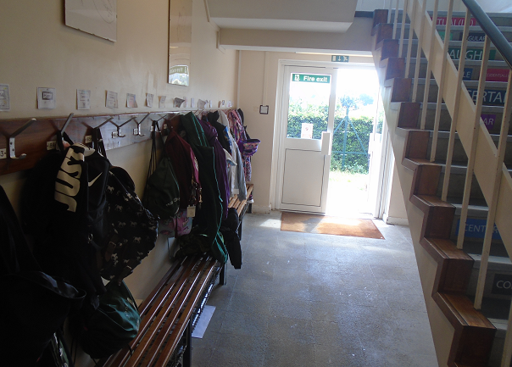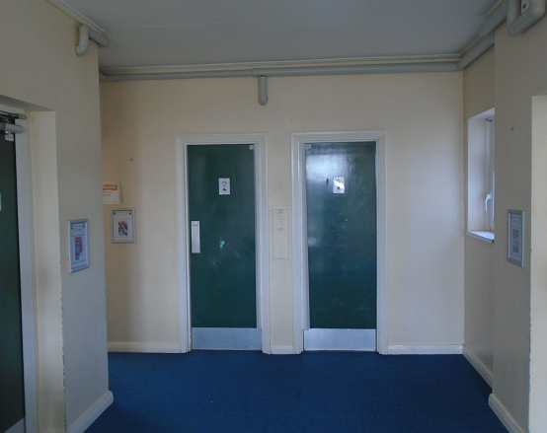

I will have break time on the Junior playground.

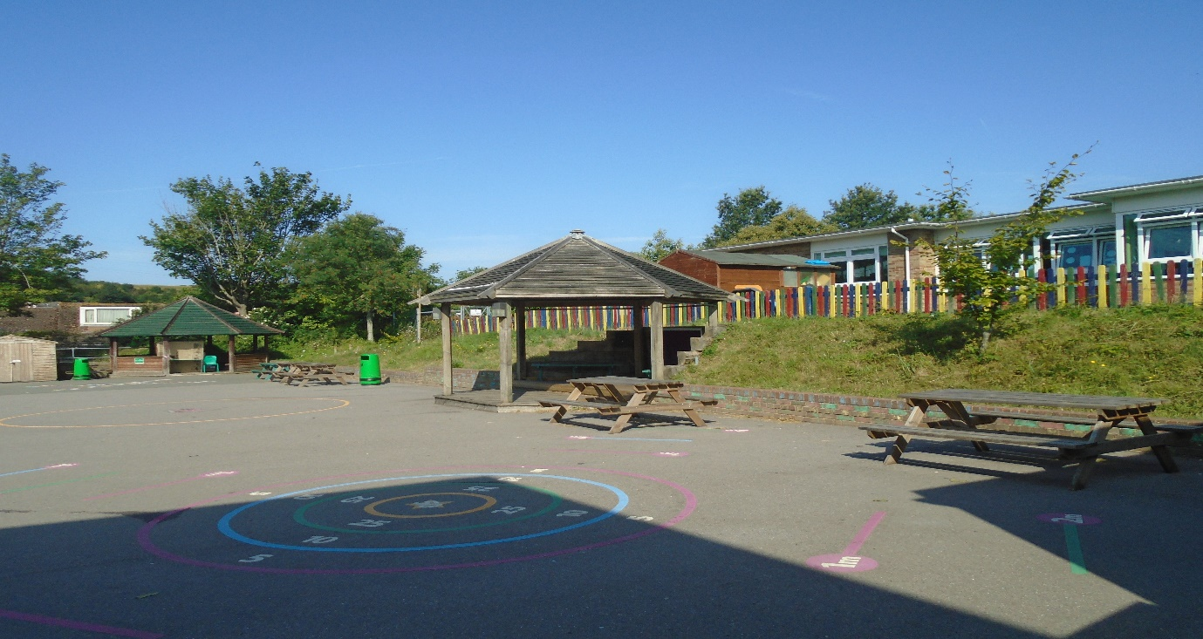

At lunch time I will go out onto the Junior playground first and wait until Year 4 are called into the Junior hall, where I will eat my lunch with my classmates.

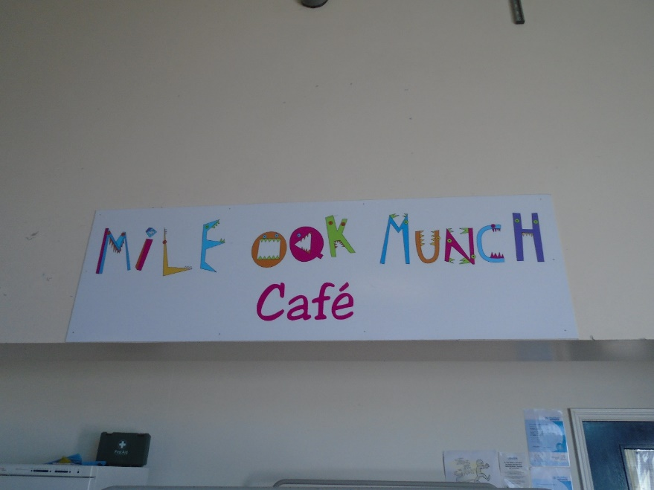

When school finishes at 3.20pm I will meet my adult on the playground and leave through the Junior gate.



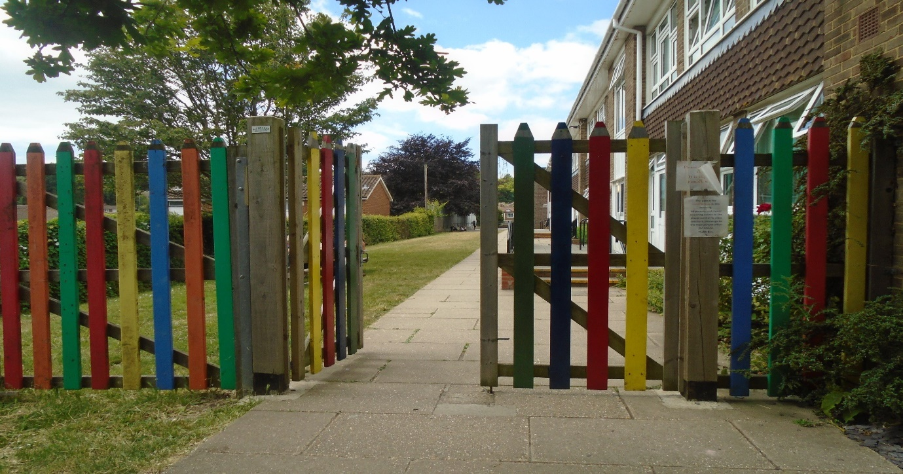

Welcome to Year 4!