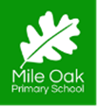
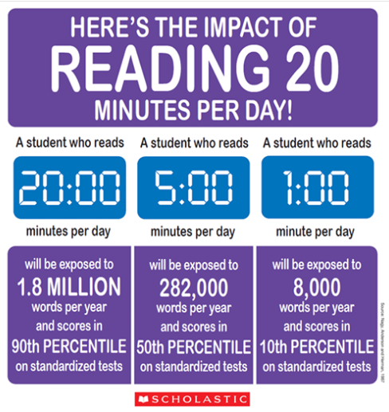
Reading Matters!

Reading role models
As parents we read all the time, but not necessarily books.
We read the news, whether on social media, apps or in print. We read magazines that match our interests. We read instructions and manuals. Children often don’t often see us doing this, or are unaware that we are actually reading.
We need to make sure that the children see that we are reading and why we are doing it.
Often our reading comes under two headings; -Reading to inform -Reading for pleasure Reading to inform is where we are reading to find out something. Whether this is the news, weather or more information that will help us in our day to day lives.
Take the time to tell your children what you are reading and why you are reading it. Where possible it is great for them to actually see you reading, whether it is a book or a magazine. This then normalises the behaviour in the house and children will see it as an option of something to do – rather than a chore or something they have to do in school!
Bedtime stories
This seems an easy solution but latest figures from The Book Trust suggest that
only 28% of primary school aged children get a bedtime story every night.
Often this is because of time restraints but the benefits are huge.
Reading to your child everyday/night can improve their vocabulary, encourage them to read independently and can also improve parent/child relationships.
This is not just a KS1 issue. Older children love a bedtime story too (even if they won’t always admit it! Bedtime stories can be a picture book, comic, poetry, non-fiction or a chapter book. Whatever you and your child want to read.
If you don’t already do this, give it a go.
(Extra tip – Do the voices! You can have a good giggle together at your brilliant/miserable attempts at doing various accents…) If you don’t feel confident with your own storytelling abilities, there is always CBeebies bedtime story – but I’d advise this as a family activity rather than the children on their own, then you can all talk about the story afterwards.

Reading is great
Reading for pleasure is greater!
Sharing stories at home is a fantastic way to encourage children to read for pleasure! We hope that some of these tips will help your family’s reading journey

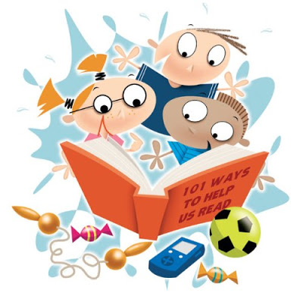
Book talk
Sometimes, children will just want to sit and listen to a book because they are so engrossed in the story. This is completely fine, there is no need to quiz them after every chapter that you read. But sometimes informal book talk can be a fantastic way to discuss what has been read. Making connections between the story and real life or another story is a great idea. ‘Ooh, that character reminds me a bit of granny because ….’
‘Can you remember when we got lost in the woods and had to carefully follow the muddy trail…’
Talking about a book with your child can make them see things that they might not have spotted or connections that they might not have made previously.
How does the story make you feel?
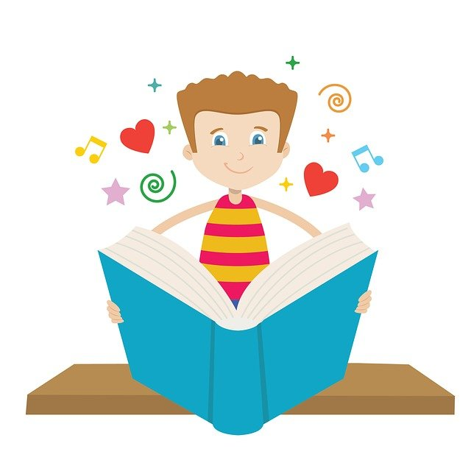
Some children find it hard to articulate their feelings, so if it is modelled for them by adults it can help them understand their own feelings. Here are three videos of a teacher sharing stories with his own children and having informal book talk along the way.
The Queen’s Handbag – Steve Anthony https://youtu.be/oBbwUW5QuDI
Old Hat – Emily Gravett https://youtu.be/g90qekYlq3U
Hotel Flamingo – Alex Milway (chapter book) https://youtu.be/CrERzbvoupY

Allow their choices Now this one is a tricky one… It is easy to be snobby about a certain author/genre and feel that your child can read much harder texts. But if we belittle their choices, they may feel that their choices are unworthy. Some children may find comfort in re-reading a book, either one that has been read to them, or that they have previously read themselves. There is nothing wrong with this at all. As adults we re-watch films many times and notice new things with each viewing, the same applies with books.
Comics and graphic novels are valid reading materials and shouldn’t be looked down upon, the same goes for the popular authors like Walliams and Kinney (Diary of a Wimpy Kid).
The best analogy for this, is to imagine that books are like food… The comfort reads are not nutritional but we still love them (just in moderation). Harder richer texts are delicious, but too many can make us feel a little overwhelmed and yearning for something easier to digest! It is all about balance!
If your child is ‘stuck’ on a particular author or genre ask your child’s teacher for recommendations.

Neil Fulcher- reading
From Boddington 2020

